Lab Guide 10

Manual And Automatic Scaling

Q.1 Create one deployment using nginx image and scale it manually to 5 pods
Q.2 Create one dep and scaling up or down should happen automatically with respect to CPU usage.

Ans: 1
kubectl create deployment webserver --image nginx
kubectl get all
kubectl get pods
kubectl scale deployment webserver --replicas=5
kubectl get pods
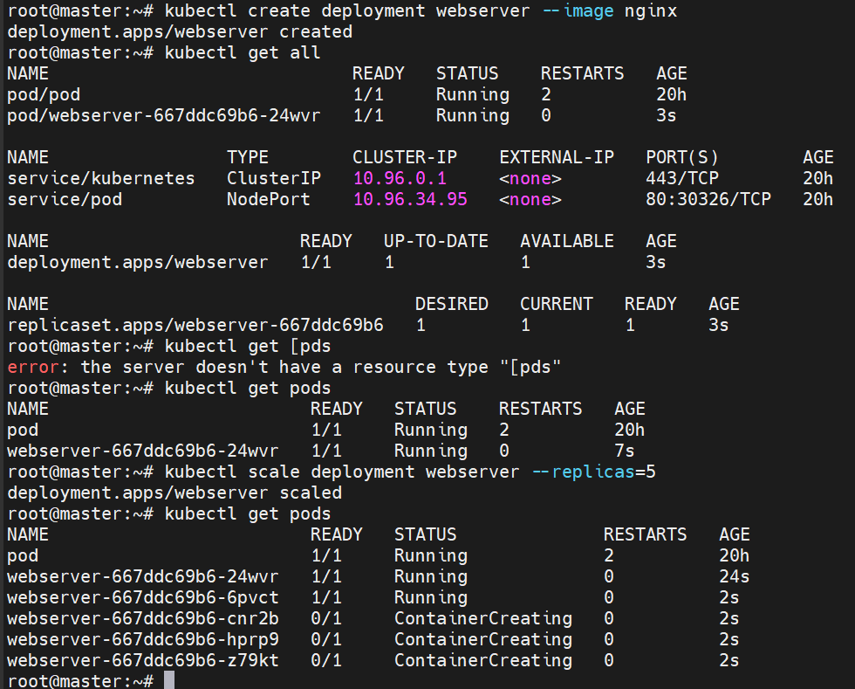
Ans.2

Create dephpa.yml file

vim dephpa.yaml

apiVersion: apps/v1
kind: Deployment
metadata:
name: php-apache
spec:
selector:
matchLabels:
run: php-apache
replicas: 1
template:
metadata:
labels:
run: php-apache
spec:
containers:
- name: php-apache
image: k8s.gcr.io/hpa-example
ports:
- containerPort: 80
resources:
limits:
cpu: 500m
requests:
cpu: 200m
---
apiVersion: v1
kind: Service
metadata:
name: php-apache
labels:
run: php-apache
spec:
ports:
- port: 80
selector:
run: php-apache

kubectl create -f dephpa.yaml

kubectl get all

kubectl top node

kubectl autoscale deployment php-apache --cpu-percent=50 --min=1 --max=10

kubectl run -i --tty load-generator --rm --image=busybox:1.28 --restart=Never -- /bin/sh -c "while sleep 0.01; do wget -q -O- http://php-apache; done"

kubectl get hpa php-apache –watch

